ISSUE STATEMENT

WE UNDERSTAND that the broader social and criminal justice concerns of police brutality are not the central issues facing Black Flagstaff community members; however, statistical data bears out a clear discrepancy in Black representation within the Flagstaff criminal justice system. A lack of diversity and representation within the local criminal justice system reflects a disparity in how both Black and other community members of color both view and anticipate likely outcomes of interactions with this system.

BACKGROUND

According to the United States Census Bureau Flagstaff’s estimated population as of July 1. 2019 was 75,038 people. The following is the race and Hispanic origin breakdown:
White alone 78%
Black or African American alone 2.3%
American Indian and Alaska Native alone 8.8%
Asian alone 3.2%
Native Hawaiian and Other Pacific Islander alone 0.2%
Two or more races 4.6%
Hispanic or Latino 19.0%
White alone, not Hispanic or Latino 64.2%

The number of African Americans arrested by the Flagstaff Police Department in 2019 was 4.0%, with the highest being in the areas of shoplifting (6%), disorderly conduct
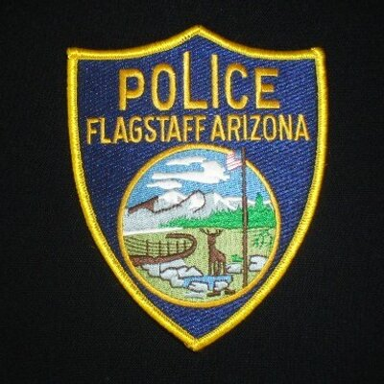

(4%) and aggravated assault (4%). Domestic violence was at 3%. All other offenses were 2% or less.

The number of officers is only 1.52 per 1,000 people, which is low. As of 2020, the Flagstaff Police Department reported zero Black officers or civilian personnel.

A recent presentation provided to the Flagstaff City Council discussed the potential for training for officers in the way of implicit bias, racial profiling, etc. Still outstanding is the question of what training civilians receive in these areas.

CONTEXTUALIZATION

To distinguish the terminology of this discourse, it is important to note the difference between the concepts of social justice and criminal justice. Social Justice, generally speaking, is the overarching principle of right and wrong in society; it is our broadly accepted societal definition of what is fair and unfair. Criminal Justice, a specific subset of Social Justice, is the specific principle of what is right and wrong, fair and unfair, according to the law. The two principles are intrinsically linked. What we are questioning in this dialog is whether the criminal justice system in Flagstaff has the tools, resources, and methodologies in place to fully address questions of equity, fairness, and justice within the African American community of Flagstaff. We recognize the engagement of the local criminal justice system with the African American community as an essential part of the ongoing, broader conversation of criminal justice within Flagstaff.

Recent conversations in Flagstaff regarding policing and engagement of the Black community with the local criminal justice system have focused on the nature of interactions with the police, budgetary concerns, salaries and wages, etc. Recently, the Flagstaff Unified School District Anti-Racism task force shared a potential goal of adding School Resource Officers as part of their efforts to ensure more positive interaction with African American children. However, further positive programming—i.e. a Police Athletic League, or other programs geared toward positive interactions with African American youth—have not yet been publicly presented.

The police are only one link in the criminal justice system. Statistics of the racial/ethnic breakdown of staff and similar breakdowns of the number of cases filed and prosecuted, the number of guilty and no contest pleas, and a statistical analysis of convictions by courts and juries are further focuses that might be engaged as the City continues this ongoing discussion. Demographics within the broader criminal justice system, including various prosecutors’ offices and other local/county/state offices and attorneys and staff, the defense bar and their staff, and the judicial framework (judges, clerks, staff, etc) within Flagstaff and Coconino County courts are further insights that might weigh on our understanding of the full breadth of the criminal justice system’s engagement with the African American community.

This is not a one-time-fix-all effort. This conversation will include a commitment to outlining a workable, flexible plan for the next 5-10 years. This includes a commitment from all levels of the community, from the top levels of city officials to the citizen level. The broader goal is to work to abolish systemic racism in Flagstaff’s socio-economic and justice systems.

KEY QUESTIONS

PLEASE INSERT KEY QUESTIONS FOR COMMUNITY FORUM ATTENDEES TO CONSIDER IN RELATION TO THIS TOPIC. FOR EXAMPLE:
- WHAT do you feel are the primary Social and Criminal Justice concerns facing the Black community of Flagstaff?
- WHAT direct experience(s) have you had with law enforcement or the criminal justice system in Flagstaff, if any?
- WHAT do you feel needs to change in order to ensure continued positive development of the Flagstaff community in this area?
- WHAT does change look like to you when it comes to Social and Criminal justice?

